**Human Resources Migration Workflow System**

Human Resources Machine

**Section 2. Requirements**

**Section 2.1 Requirements Descriptions**

*(Describe concisely your project’s requirements after collecting the information on users, business functions, and interactions with other business functions. Ensure that your requirements include precise descriptions of interactions with other business functions as they are critical to your system.)*

Our system involves a lot of business functions, and these business functions are closely linked.

1. **For an applicant**
   1. **Register**: Anyone can register an account with personal information (e.g., email, name)
   2. **Log in**: Registered users can log in using the registered email or username. This is available only after registration process is finished
   3. **View the recruitment positions**: Users can view the recruitment positions of all companies. This is available no matter the user is logged in or not.
   4. **Apply for positions**: Users can apply for one or more recruitment positions. This is available only after the users has logged in.
   5. **Upload the resume**: Users will need to upload his or her resume so that the application can be completed. Applicants must upload a resume for each application he or she applied for.
   6. **Interview**: After the application is completed, the candidate starts a round of recruitment process. In a typical recruitment process, the workflow includes resume review, 1st interview, 2nd interview, …, HR review, and so on.
   7. **View the status of each application**: Candidates will be able to get the status of all their applications. In addition, applicants can also get their own unique “recruitment calendar” with important timings (such as the time for the 1st interview).
   8. **Interview notification**：Before the important time arrives, the system will send an email to the applicant for reminding.
2. **For an HR manager**
   1. **Control the workflow of each candidate:** HR managers can control the workflow for each candidate once a candidate apply for a certain position.
   2. **Assign the corresponding interviewer**. HR managers will be able to assign corresponding interviewer to each candidate to get the interview going well.
   3. **Publish job information**: HR managers can also publish information for available positions.
   4. **Design the recruitment process**: HR managers can decide how the recruitment process go.
   5. **View the interview performance of each interviewee**: for the interviewer.
3. **For an interviewer**
   1. **Get candidates' resumes**: Interviewers will be able to view each candidate’s resume to better know the candidate.
   2. **Modify the interview time**: Interviewers can privately negotiate with the interviewer (by mail, telephone, etc.) and then modify the interview time. Of course, we will inform the interviewee by email once the interviewer modifies the interview time.
   3. **Score the interviewee's interview performance**: For reference by the HR manager to decide whether to admit the interviewee, the interviewer will be able to evaluate and comment the interviewee’s performance in the interview.

To better understand a recruitment process you can refer to **Figure 1**. For a more general view of the requirements and user stories, you may refer to **Table 1**.

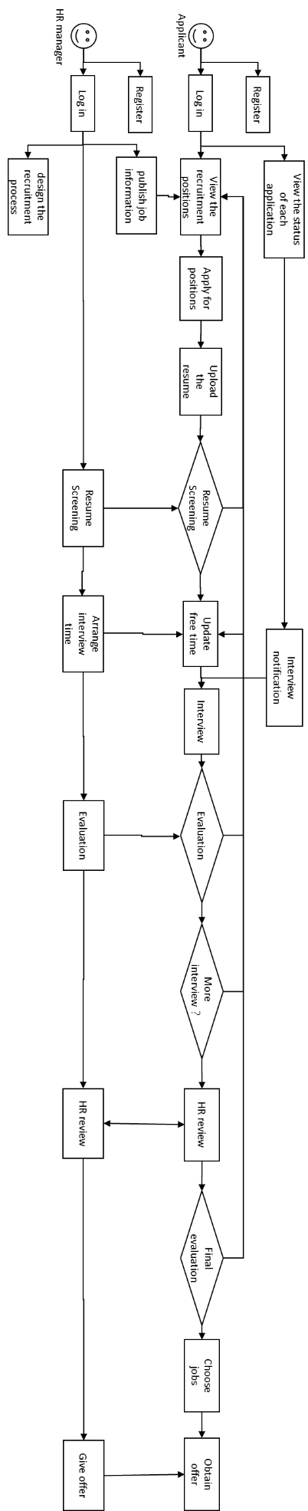

**Figure 1 A typical recruitment process**

**Table 1**.

**Table 1 User Stories**

|  |  |  |
| --- | --- | --- |
| ***Role*** | ***Aim*** | ***Function*** |
| Applicants | use the application | login/out |
| apply for a position | send a resume to some companies |
| don't miss the deadline | calender management |
| understand the stage of the resume | check the stage of each resume that has been submitted |
| ensure smooth communication | modify contact information |
| Interviewers | use the application | login/out |
| give a result and comment | grade an interviewee |
| view resumes | view online resumes of applicants |
| HR managers | use the application | login/out |
| design recruit workflow | assign workflows for each position |
| assign interviewers | assign interviewers to each applicant |

**Section 2.2 Your Meeting Log**

|  |  |  |  |  |  |
| --- | --- | --- | --- | --- | --- |
| ***No*** | ***Date and time*** | ***Duration*** | ***Location*** | ***Discussion topic*** | ***Attenders*** |
| 1 | 3/17/2018:3:00pm | 2.5 hrs | 709 Gewu | Project selection | all members |
| 2 | 3/23/2018:3:00pm | 2 hrs | 709 Gewu | Requirements | all members |
| 3 | 3/25/2018:8:00pm | 2hrs | 709 Gewu | Requirements | all members |
| 4 | 4/1/2018:4:00pm | 2hrs | 709 Gewu | Requirements | all members |